Manuscript Types: Original Research/ Literature Review/ Book Review/ etc

The title is a maximum of 15 words in English center alignment bold roboto with 14 sentence case

First Author*¹, Second Author², Third Author³
1, First Afiliation, Country
2, Second Afiliation, Country
3, Third Afiliation, Country

* Corresponding author.  Corresponding Author  E-mail address:  author@email.ac.id  Article Info  Keywords:  First keyword; second keyword; third keyword (List 3-6 keywords specific to the article yet reasonably common within the subject discipline.) | Abstract  A well-written abstract allows the reader to identify the main points of a document, assess its relevance to their interests, and decide whether to study the text in its full quickly and correctly. The Abstract should clearly identify the problem, the suggested strategy or solution, and highlight the most important findings and conclusions. It should be informative and entirely self-explanatory. The Abstract ought to be between 200 and 250 words long. The past tense should be used to write the abstract. Abbreviations should not be used; instead, standard terminology should be followed. You don't need to cite any academic works. In addition to the keywords already included in the title, the keyword list offers the chance to add additional keywords used by the indexing and abstracting services. In addition to the keywords currently included in the title, the keyword list offers the chance to include an additional 5 to 7 keywords that are used by indexing and abstracting services.

1. Introduction
The background information, the issue statement, the pertinent literature on the research topic, the suggested strategy, methodology, or method, and the new significance or uniqueness of the study should all be included in the introduction [1]. The bibliography is formatted and referenced using the Vancouver style [2]. The words that are in other languages are italicized. It is advised that authors arrange their articles as follows: introduction, research methodology, results and discussion, conclusion, and references. If necessary, acknowledgments and annotations can be included before the references section. Manuscript submissions must be made via the website jesica.itsk-soepraoen.ac.id by following the required registration process. Manuscript registration and submission are completely free of charge. Based on the article format specified in the provided template, the manuscript must be at least 6 pages long and no more than 8 pages long.

2. Research Method
Research design, research procedure (represented by algorithms, pseudocode, or other relevant objects), how to test, and the data collecting process are all included in the research method [3], [4]. References should be included to substantiate any descriptions of research methods. Tables and/or figures may be used as illustrations in articles. After the paragraph in which they are quoted in the main text, the figure and table are presented in the center (center alignment). The text should cite every illustration. A blank line should be placed before and after the figure or table, with one space (10 pt) for the text paragraph and two spaces (10 pt) for the next part.
It is necessary to identify and caption both the figure and the table. Italic type, center alignment, 10-point font size, and single spacing are used for the name and caption. Make sure that neither the name nor the caption crosses any columns or pages. Figure names and captions might go below the figure, whereas table names and captions could go above the table. The figure/table caption and name should be separated by a dot. The names of the figures and tables are given Arabic numbers, and they are then given numbers in the order in which they occur in the main text. Table 1, Tables 1, 3, and 4, Tables 3 through 5, and so forth are the proper names for the many tables. Similar names for figures should be used for Figure 1, Figure 8, and Figure 9, etc. Abbreviations should never be used in sentences that begin with a figure reference.
It should be easy to understand the text in the figure and table. The quality of the figures and graphs must be high. Additionally, the graph's line styles must be distinct. All colored images in print journals will be shown in black and white. The table is not an image. The spacing between columns or between lines must be considered to prevent mistakes when setting up the display. One example of a figure that is easy to see is Figure 1. Use a table with no borders to make the organization of a figure that includes certain images simpler. The example table is shown in Table 1. The mathematical equation should not be written as an image but rather with equation tools. The mathematical equation is center aligned, placed right after it is referenced in the text, and numbered in accordance with the sequence of presentation.

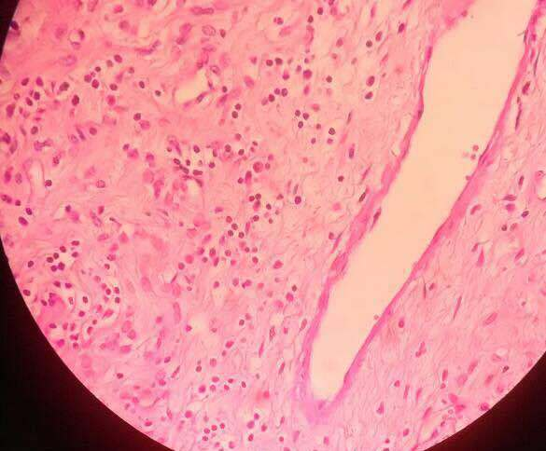  (a) | 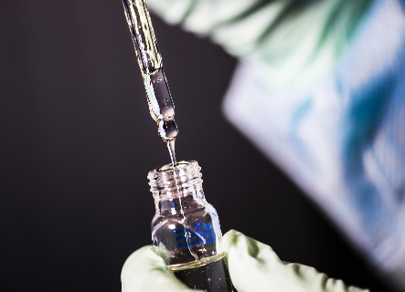  (b)
Figure 1. The example of figures that can be seen clearly

Table 1. An example of table caption
Variable | Speed (rpm) | Power (kW)
x | 10 | 8.6
y | 15 | 12.4
Z | 20 | 15.3

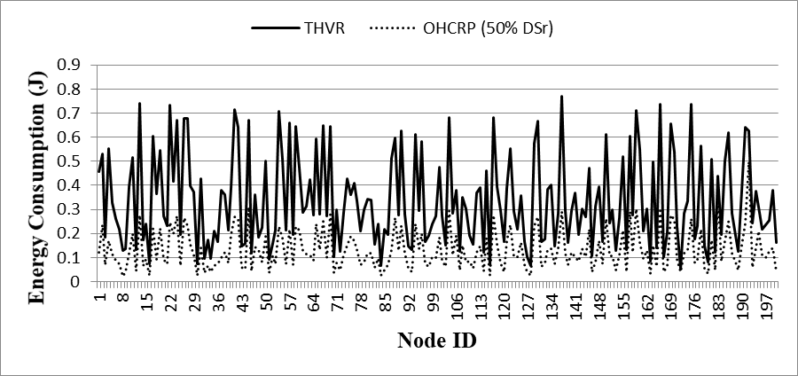
Figure 3. The example of figures that can be seen clearly

Arabic numerals are written using inside brackets and the proper orientation. Each mathematical formula must be referenced in the text. Before and after a mathematical equation, a blank line should be provided with one space of 10 points for the text and two spaces of 10 points for the next portion. In the text, the equation(s) should be referred to as Equation 1, Equations 1 and 3, Equations 1 to 5, and so on. If any of these words begin a phrase, refrain from using abbreviations. The illustration of a mathematical equation is Equation 1.

$Corr=\sum_{i,j=0}^{L-1}{\frac{\left({i-μ}_{x}\right)\left({j-μ}_{y}\right)P\left(i,j,d,θ\right)}{σ_{x}σ_{y}}}$ (1)

Where $μ_{x}=\sum_{i,j=0}^{L-1}{i.P(i,j,d,θ)}$, $μ_{y}=\sum_{i,j=0}^{L-1}{j.P(i,j,d,θ)}$, $σ_{x}=\sum_{i,j=0}^{L-1}{{(i-μ_{x})}^{2}.P(i,j,d,θ)}$, $σ_{y}=\sum_{i,j=0}^{L-1}{{(j-μ_{y})}^{2}.P(i,j,d,θ)}$. The notation explanation of a mathematical equation should be written in the Notation section, which comes before the References section and should use SI units.

3. Results and Discussion
This part provides a thorough discussion while also outlining the research findings. Results can be shown in tables, graphs, figures, and other formats that are simple for the reader to interpret [5]. There are various ways to break up the topic.

3.1. Sub Section 1
The problems should be clarified from general to specific in writing. To describe each issue, use pertinent references. Every used reference must be listed in the bibliography or references section, and every reference listed there must be mentioned in the body of the essay.

3.2. Sub Section 2
One core statement and numerous supporting sentences make up each paragraph. The explanations ought to be given methodically and should explain what the writers do in relation to the data, techniques, or stages of the research.

4. Conclusion
As stated in the "INTRODUCTION" part, provide a declaration that what is anticipated can ultimately lead to the "RESULTS AND DISCUSSION" section, demonstrating compatibility. Additionally, the promise of the advancement of study findings and the application of future studies (based on results and debate) can be added.

Acknowledgement. The heading should not be given a number and should instead be considered as a subsubsection heading.

References
APA (American Psychological Association) Style requirement for references in a paper is 15 minimum references. Reputable international journals or proceedings must be used as the primary references and a doi hyperlink must be included. All citations should point to the most relevant and recent sources. Using reference tools like Mendeley, references and citations are required. Please follow the reference writing instructions in this manual.

References

Mangialavori, S., Russo, C., Jimeno, M. V., Ricarte, J. J., D’Urso, G., Barni, D., & Cacioppo, M. (2021). Insecure attachment styles and unbalanced family functioning as risk factors of problematic smartphone use in Spanish young adults: A relative weight analysis. European Journal of Investigation in Health Psychology and Education, 11, 1011–1021. https://doi.org/10.3390/ejihpe11030075

Mastrotheodoros, S., Can´ario, C., Gugliandolo, M. C., Merkaˇs, M., & Keijsers, L. (2020). Family functioning and adolescent internalizing and externalizing problems: Disentangling between-, and within-family associations. Journal of Youth and Adolescence. https://doi.org/10.1007/s10964-019-01094-

Nweke, K. O., Umeaku, N. N., Anyaorah, G. C., Ofoma, E. B., & Azubuike.. (2021). Personality traits and smartphone addiction as correlates of academic performance. African Journal For The Psychological Study Of Social Issues, 24(2), 124–136. http:// www.ajpssi.org/index.php/ajpssi/article/view/481.

Oei, T. P., Sawang, S., Goh, Y. W., & Mukhtar, F. (2013). Using the depression anxiety stress scale 21 (DASS-21) across cultures. International Journal of Psychology, 48(6), 1018–1029. https://www.sukanlayasawang.com/uploads/1/1/2/5/11252231 /dass21_thai_version.pdf.

Panova, T., & Carbonell, X. (2018). Is smartphone addiction really an addiction? Journal of Behavioral Addictions, 7(2), 252–259. https://doi.org/10.1556/2006.7.2018.49

Przybylski, A. K., Murayama, K., DeHaan, C. R., & Gladwell, V. (2013). Motivational, emotional, and behavioral correlates of fear of missing out. Computers in Human Behavior, 29(4), 1841–1848. https://doi.org/10.1016/j.chb.2013.02.014

